Safety, Health and Environment (SHE)

GCC COVID-19 RISK ASSESSMENT PROCESS FOR SCHOOLS (FROM STEP 4)

This is an update of the GCC COVID-19 Risk Assessment to support schools and educational settings from Step 4 of the Government Roadmap from 16th August 2021*. The aim of the risk assessment is to implement protective measures in the government’s operational guidance to protect your staff, pupils and community.

This update has moved away from the Assess – Plan – Do – Review model previously used (see below) into a more traditional risk assessment format that identifies each hazard, who is at risk, guidance on what you should be doing and any further actions that are required.
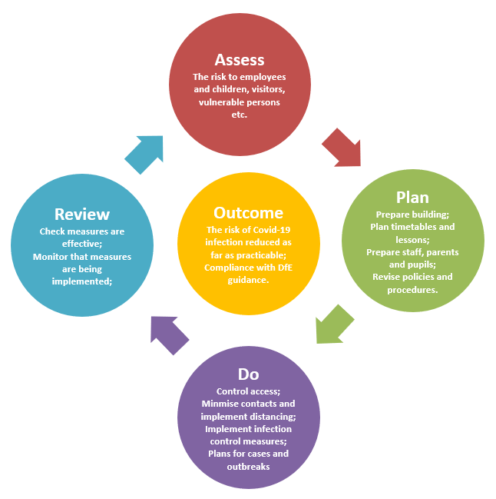
Each school/setting must consider their own situation and adapt the assessment by editing the measures where appropriate. Remove any measures that are not relevant or will not be applied in your setting and add any additional local measures that you are implementing, then complete the relevant columns.

Some people at work may have particular characteristics meaning they are at comparatively increased risk from COVID-19 (due to age, deprivation, ethnicity, pregnancy, etc.) and as employer the school must consider them in their risk assessment.

*Please note that this risk assessment may be updated before September 2021 in light of updates to government guidance.

COVID-19 Risk Assessment for Finlay Community School

Risk Assessment for Finlay Community School
Hazards | Who is at risk? | What are you already doing? | Is enough to manage the risks? | What further action is necessary? | Action by whom? | Action by when? | Done
Person showing symptoms or positive test result | Employees  Pupils  Young People  Families  Contractors  Visitors  Members of the public | - Refer to GCC COVID Response Checklist and public health advice on testing, self-isolation and managing confirmed cases of COVID-19.  - Regular communications that persons are not to come into school if they have symptoms, have had a positive test result or other reasons requiring them to stay at home due to the risk of them passing on COVID-19 (e.g. they are required to quarantine).  - If anyone in your school develops COVID-19 symptoms they will be sent home.  - An unwell child awaiting collection will be isolated in a suitable room with adult supervision.  - Staff caring for a child awaiting collection to keep a distance of 2 metres.  - PPE to be worn by staff caring for the child, including:  - a face mask worn if a distance of 2 metres cannot be maintained.  - if contact is necessary, then gloves, an apron and a face mask should be worn  - eye protection where there is a risk of fluids entering the eye, for example, from coughing, spitting or vomiting.  - Staff to wash their hands after caring for a child with symptoms.  - All areas where a person with symptoms has been to be cleaned after they have left.  - Follow threshold guidance in school outbreak management plan for reporting and managing an outbreak.  - School has sufficient supplies of PPE, face coverings, cleaning materials and hand washing/sanitising liquids.  - Update staff, pupils, stakeholders and visitors on changes in practice – Covid safe measures.  - Any pupil showing symptoms of COVID-19, parents/carers are to provide proof of positive/negative results before the pupil returns to school.  - If a pupil tests positive, all siblings will require a negative PCR result before they return to school.  - If a parent/carer insists on a pupil attending your school with symptoms, Headteacher may refuse the pupil if, in their reasonable judgement, it is necessary to protect other pupils and staff from possible infection with COVID-19.  - Contract Tracing – If we are aware that a pupil has tested positive, we will advise all the pupils in that class to have a PCR test and not wait for Track and Trace.  - Staff to wear face masks in communal areas  - Essential external visitors only  - All visitors to complete a LFT before coming into school and wear a mask.  - Staff to take LFDs twice a week.  - Any staff who are identified as a close contact, must do daily LFDs for a period of 10 days, and book a precautionary PCR test. |  | Increase the use of home testing by staff  Attendance restriction will only be recommended by the government as a last resort. | HW/TAS
Poor Personal Hygiene | Employees  Pupils  Young People  Families  Contractors  Visitors  Members of the public | - COVID-19 posters/ signage displayed.  - Frequent and thorough hand cleaning is regular practice.  - Pupils and staff to clean their hands when they arrive at school, when they return from breaks, when they change rooms and before and after eating.  - Sufficient handwashing facilities are available.  - Staff help is available for pupils who have trouble cleaning their hands independently (e.g. small children and pupils with complex needs).  - Adults and pupils are encouraged not to touch their mouth, eyes and nose.  - Adults and pupils encouraged to use a tissue to cough or sneeze and use bins for tissue waste (‘catch it, bin it, kill it’).  - Tissues to be provided.  - Bins for tissues provided and are emptied throughout the day. |  | Put in place monitoring and supervision to make sure people are following any controls you have in place, including enhanced cleaning. | HW/TAS/DH
Spreading coronavirus from contact with surfaces, equipment and workstations | Employees  Pupils  Young People  Families  Contractors  Visitors  Members of the public | - Reduced clutter and removing difficult to clean items to make cleaning easier.  - Cleaning using standard cleaning products such as detergents, paying attention to all surfaces but especially ones that are touched frequently, such as door handles, light switches, work surfaces, remote controls and electronic devices.  - Surfaces that are frequently touched and by many people in common areas to be cleaned regularly.  - Avoid sharing work equipment by allocating it on a personal basis or put cleaning regimes in place to clean between each user.  - Identify where you can reduce people touching surfaces, for example by leaving doors open (except fire doors).  - Keep surfaces clear to make it easier to clean and reduce the likelihood of contaminating objects.  - Advanced cleaning schedule for toilets and communal areas.  - Sanitising spray and paper towels to be provided in classrooms for use by members of staff.  - Thorough cleaning of rooms at the end of the day/beginning of day.  - Cleaning material provided in all classrooms |  | Put in place monitoring and supervision to make sure people are following controls, for example by implementing cleaning regimes. | HW/TAS/DH
Poorly ventilated spaces leading to risks of coronavirus spreading | Employees  Pupils  Young People  Families  Contractors  Visitors  Members of the public | - Heating used as necessary to ensure comfort levels are maintained when the building is occupied.  - Keep windows open wide enough to provide some natural background ventilation and ensure all internal doors are open to increase air flow.  - Open windows fully when rooms are unoccupied for longer periods to purge the air (e.g. lunch times and before and after school).  - CO2 monitors issued to all classes, this will enable staff to take appropriate actions such as increasing ventilation in classrooms.  - Action taken to prevent occupants being exposed to draughts. For example, partially open high-level windows as oppose to low-level windows, close external doors and arrange the furniture if appropriate and possible.  - Occupants encouraged to wear additional, suitable indoor clothing. (If they have to wear coats, scarves and other outdoor clothing the room would be considered too cold and the above steps must be considered).  - All staff meetings will take place via Zoom. |  | Identify any poorly ventilated spaces take steps to improve fresh air flow in these areas. | HW/TAS/DH
Increased risk of infection and complications for workers who are clinically extremely vulnerable and workers in higher- risk groups | Employees  Pupils  Young People  Families  Contractors  Visitors  Members of the public | - Identify who in the work force could be clinically extremely vulnerable and refer to government guidance and HSE and PHE guidance on protecting vulnerable workers during the pandemic on how to support workers in higher-risk groups and those who are clinically extremely vulnerable.  - Carry out a risk assessment of pregnant workers to identify the risk and measures to be taken.  - Some pregnant workers will be at greater risk of severe illness from coronavirus and they should stay at home as much as possible and work from home if they can.  - Where adjustments to the job or working from home is not possible pregnant workers will be suspended from work on paid leave. |  | Guidance on who is clinically extremely vulnerable and what further support may be available from Public Health England.  Keep under review completed individual risk assessments for pregnant workers. | HW/TAS
Airborne spread of COVID | Employees  Pupils  Young People  Families  Contractors  Visitors  Members of the public | - Face coverings to be worn by staff, parents and visitors (unless exempt), when moving around the premises.  - One way system to be implemented for drop off and pick up times for parents.  - Children to avoid mixing in school, unless in a year group. Children will sit in year groups for breakfast club and lunch.  - All afterschool clubs suspended.  - Face coverings recommended on school transport |  |  | HW/TAS

Completed by: | Tracy Satherley | Date | 02/09/2021

Signed by

T Satherley (SBM) | Hannah Williams (Acting Headteacher) | Daniel Gillingham (Chair of Governors)
Date | Date | Date

Review Due | Reviewed by | Date
30.11.21 (or sooner if needed) | Tracy Satherley | 22/11/2021

Reviewed | Reviewed by | Date
29/11/2021 | Tracy Satherley | 29/11/2021

Review Due | Reviewed by | Date

Review Due | Reviewed by | Date

