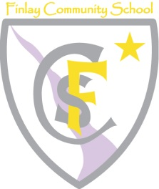
Sports Premium Funding Statement 2017-18
Allocation 17/18 | £14,324
Brought Forward 16/17 | £ 1,608

Objectives | Amount Spent | Success Criteria | Impact and Evidence
To purchase Gloucester Sports Network membership and compete in all sports competitions between cluster schools | £3350.00 | - Ability to participate in specialist sporting events  - Ability to utilise specialist sports coaches for teaching sessions and CPD  - Continue to compete in competitive sport events throughout the year
To purchase Gloucester Primary Sports Football Association membership and compete in all sports competitions between cluster schools | £135.00 | - Ability to compete in competitive sport events throughout the year  - Ability to participate in specialist sporting events
Maintain and invest in P.E resources | £5198.00 | - Improve resources for teaching and learning of PE, allowing children to take part in high quality games and sports.  - A new sports kit for competitions.
Zumba Coach | £780.00 | - Captivates both boys and girls into learning, children more active
Release time for Subject leads | £6469 | - Achieve ‘Sports mark award’  - Curriculum more focused on Healthy Outcomes for pupils  - Curriculum more inclusive for targeted children  - Higher participation of targeted hard to engage pupils

